Have profile or game setting with a default ball and/or spare ball? User changes if they end up throwing something different? That way they won’t have to choose one each time.

Maybe in the future build out a standard approach for strike or certain spares?

Why does the stats page take so long to load?

Do we want to keep track of scores in Practice before the league or just use for insights?

Add delete game feature if you accidentally add a score and actually want to full log?

Under games, change “add with score” to “Add Score Only”

Sessions – move “Start a Session” form to the top, or have as separate button at top and take to new form page.

Now Bowling – Frame # (add Throw/Ball # as well)
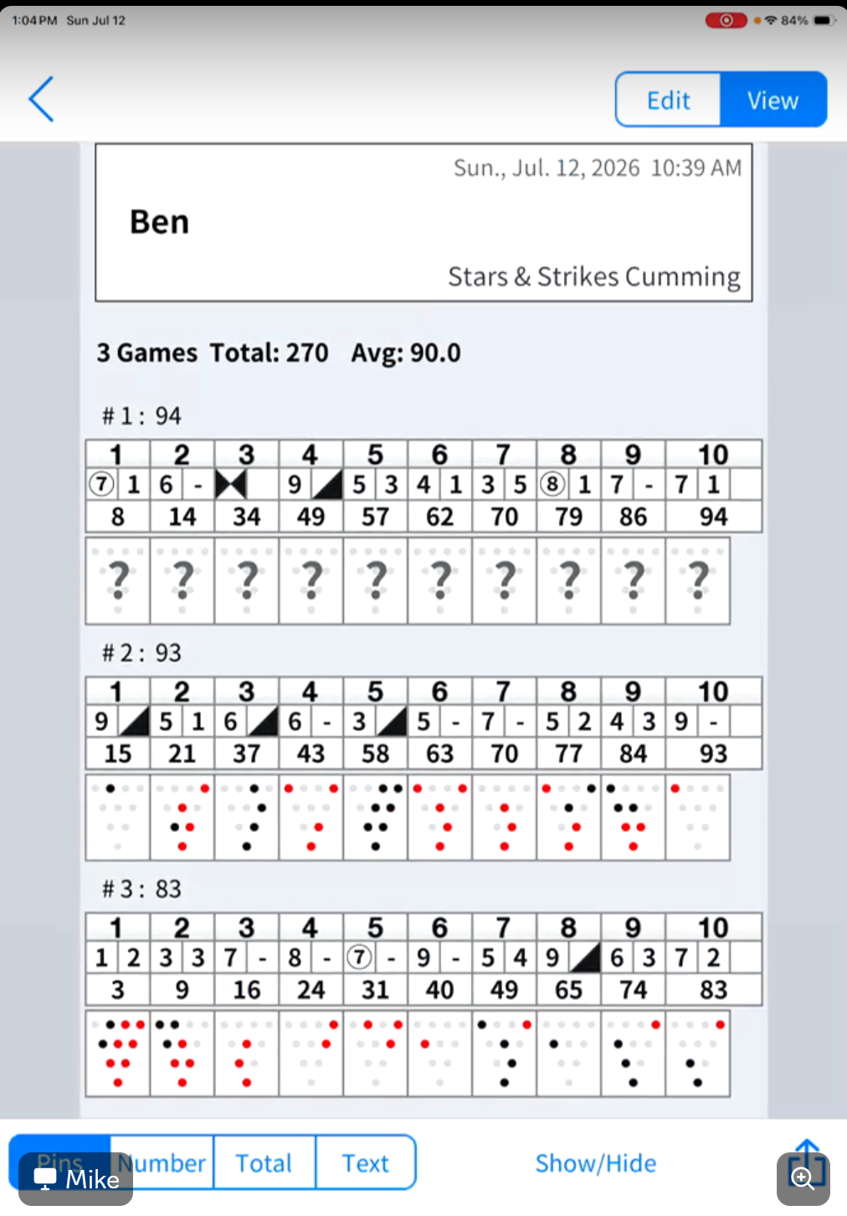

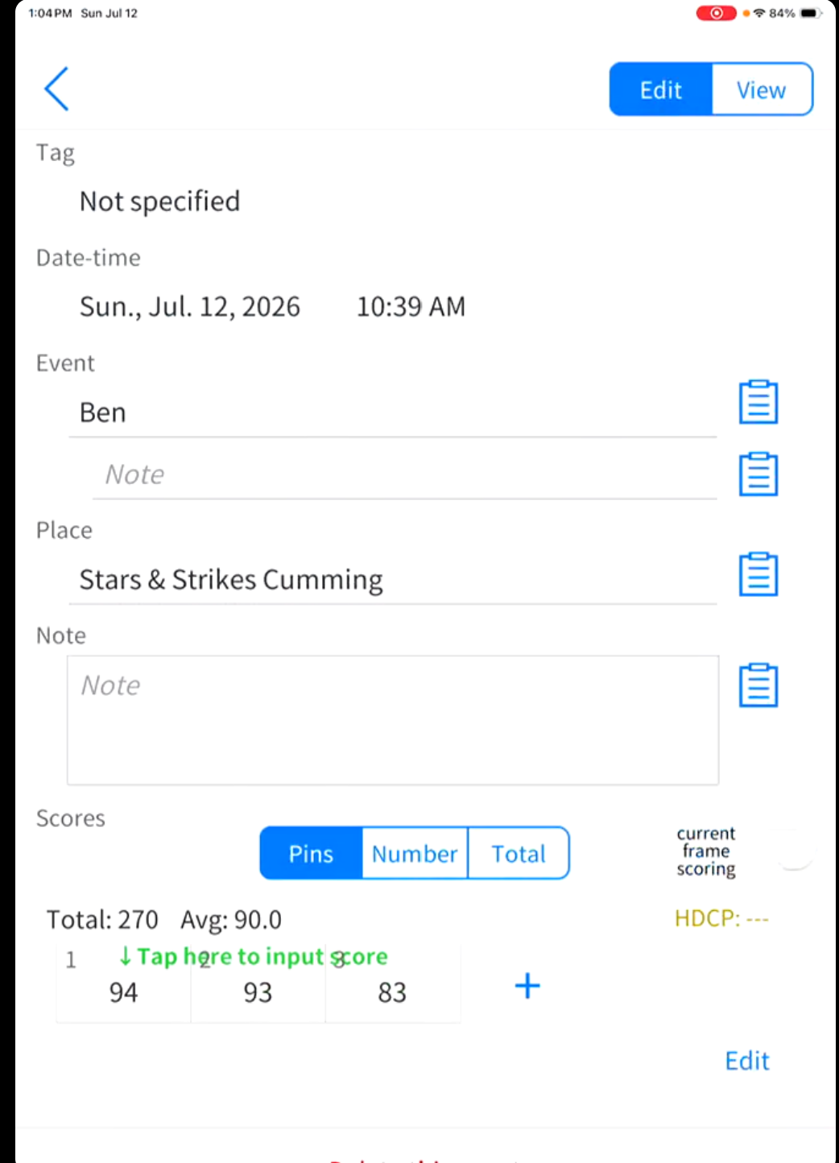

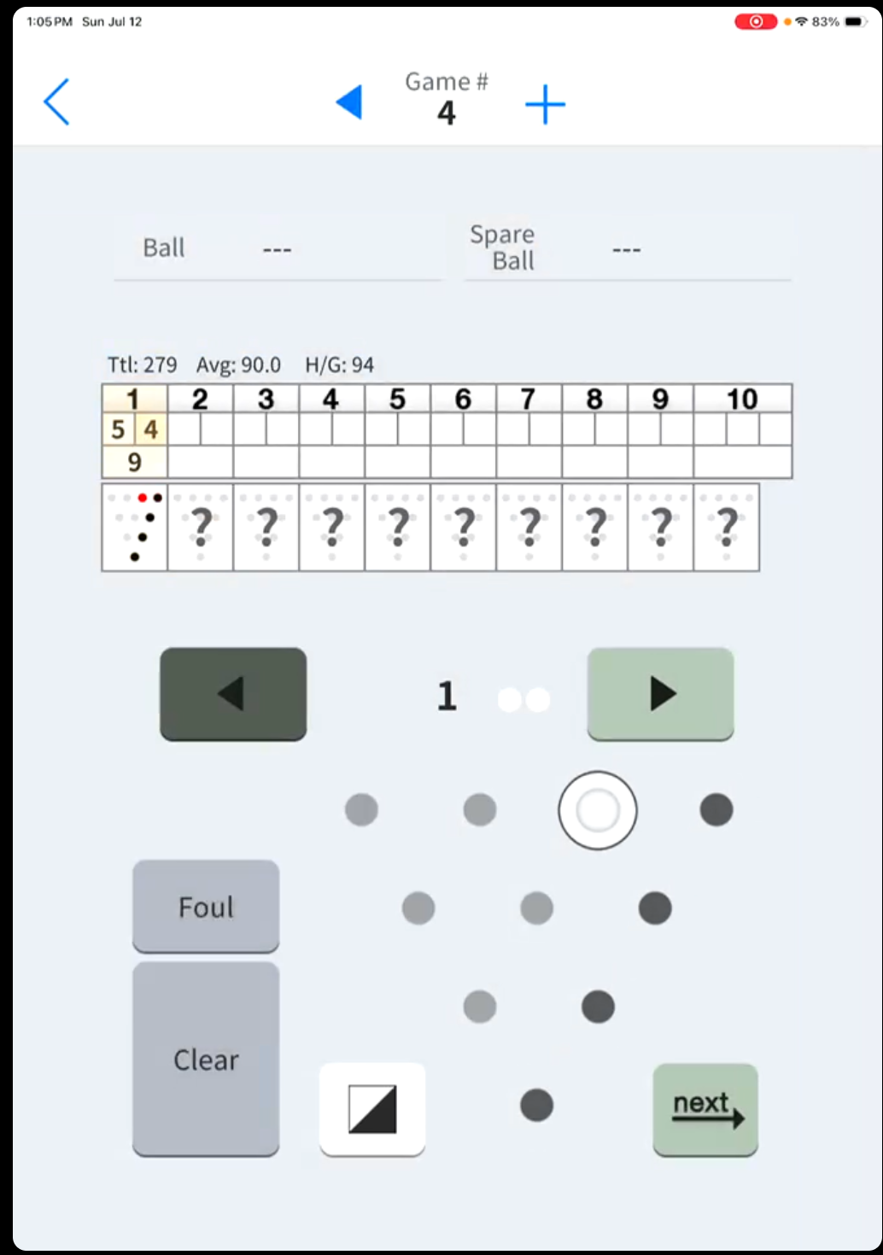

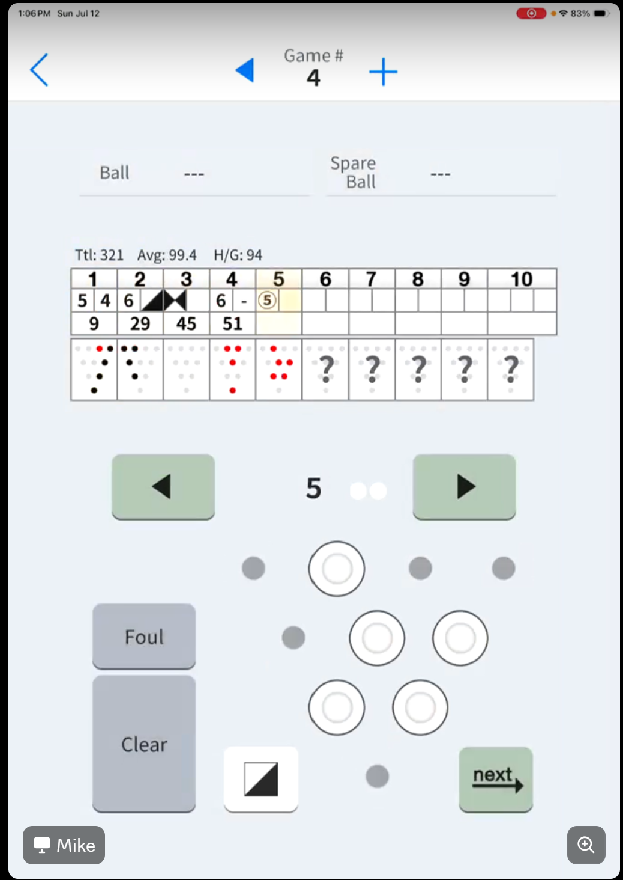

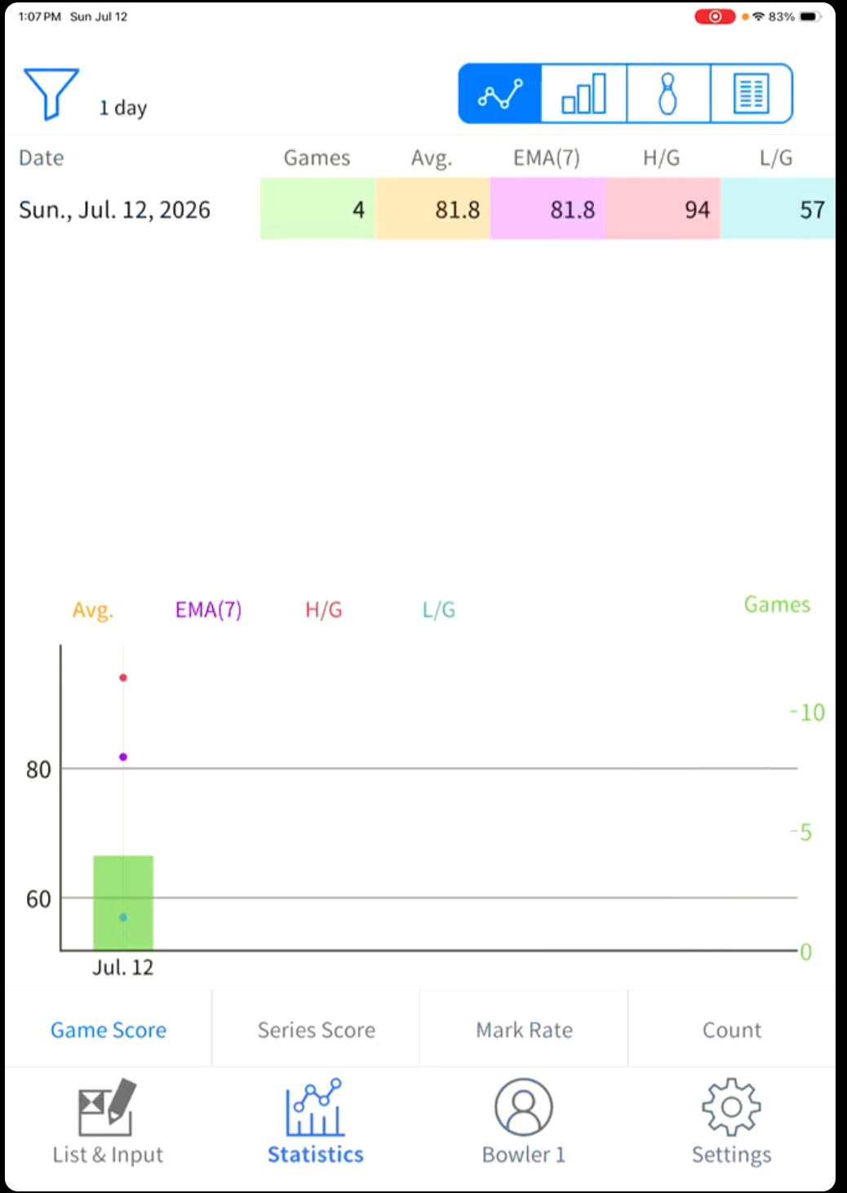

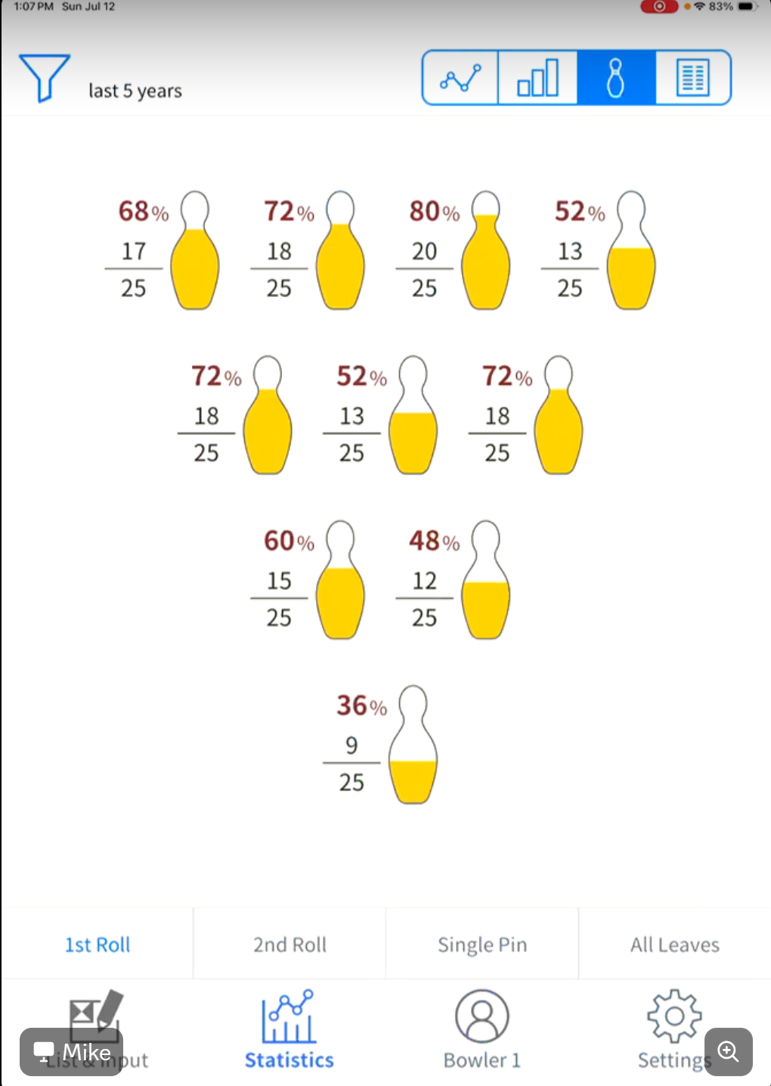

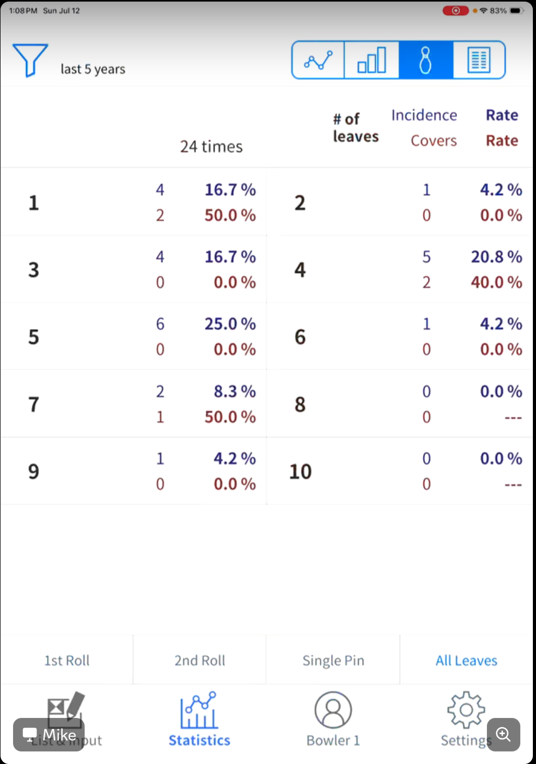

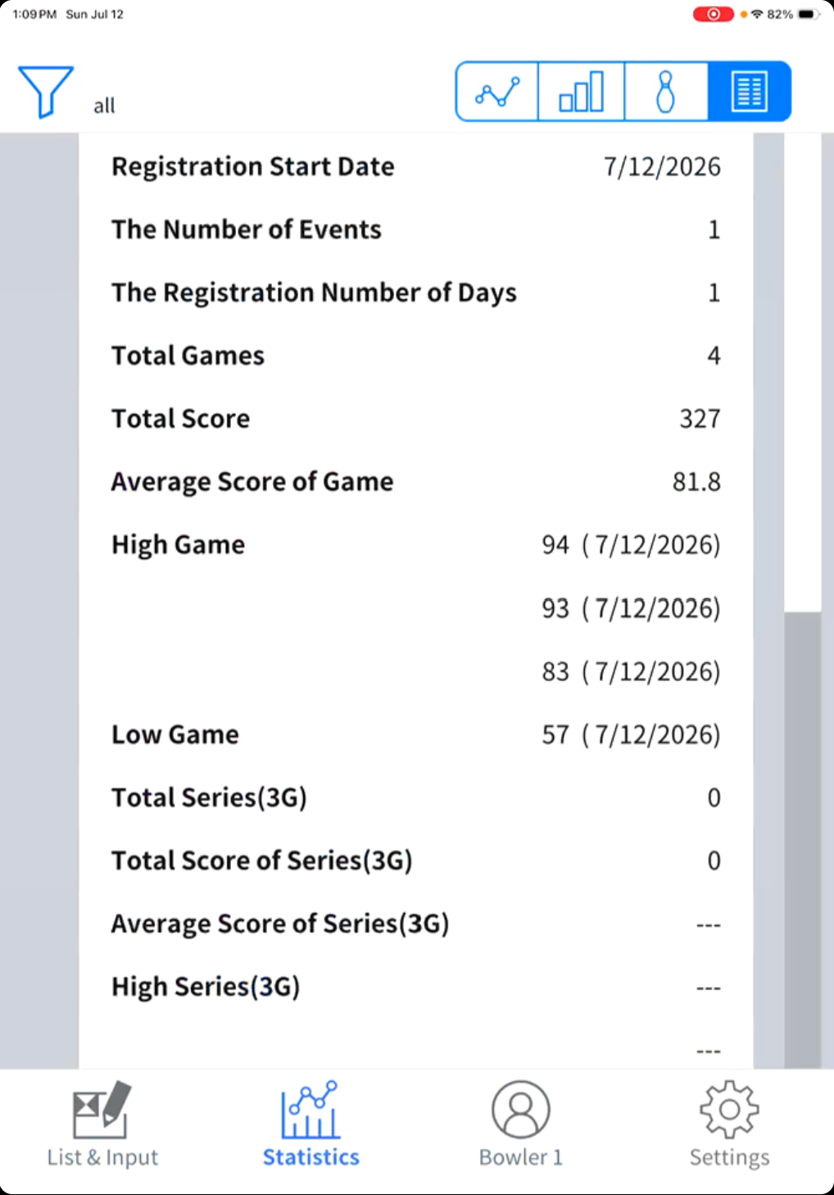

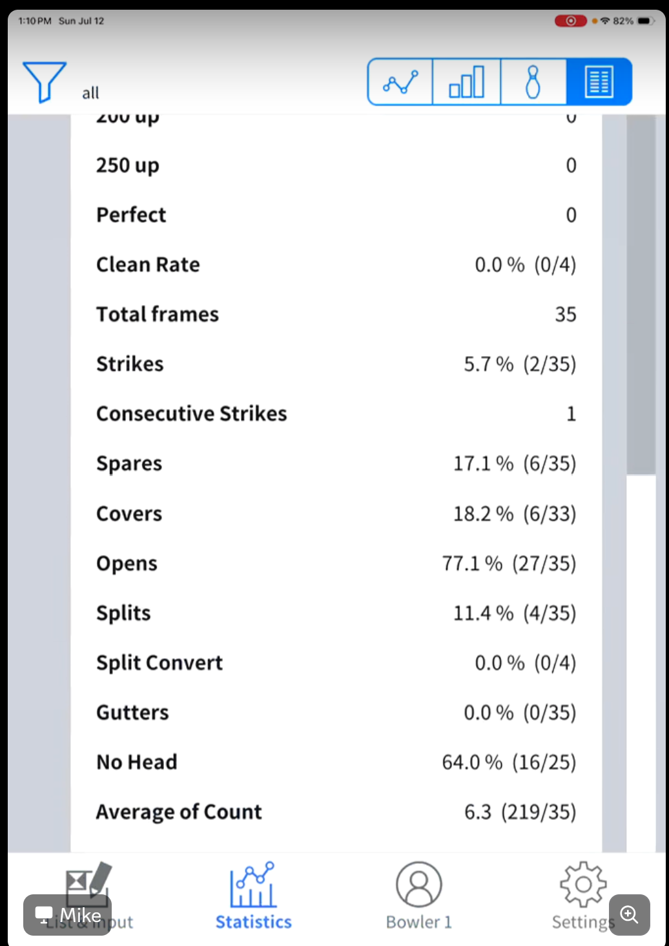

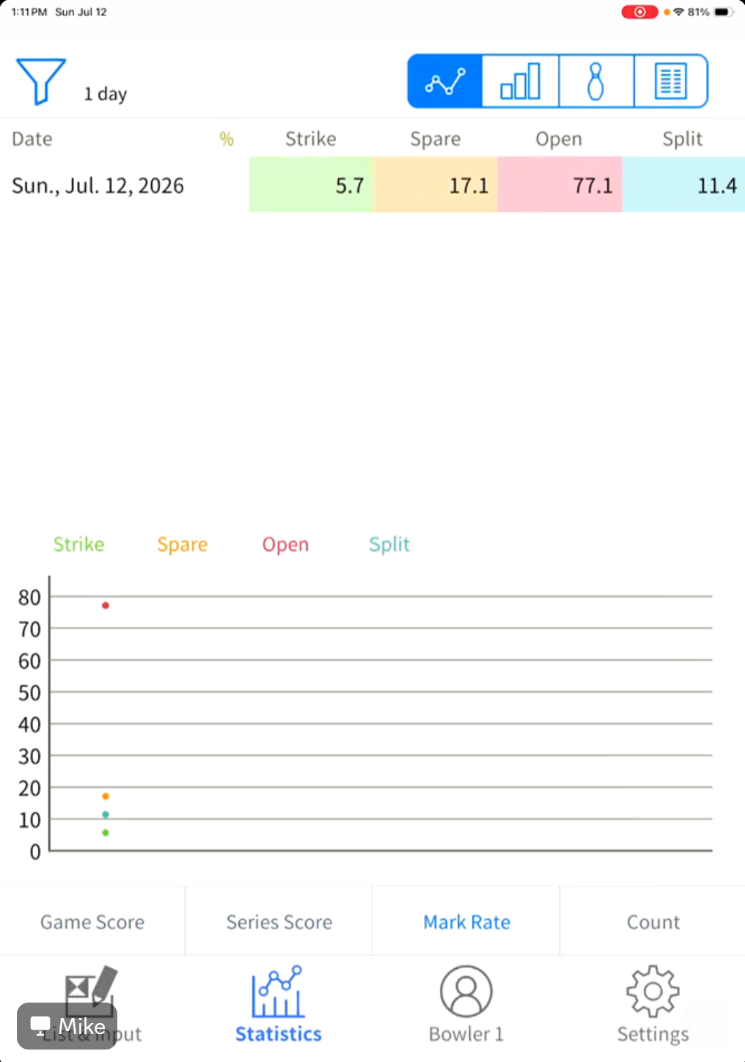

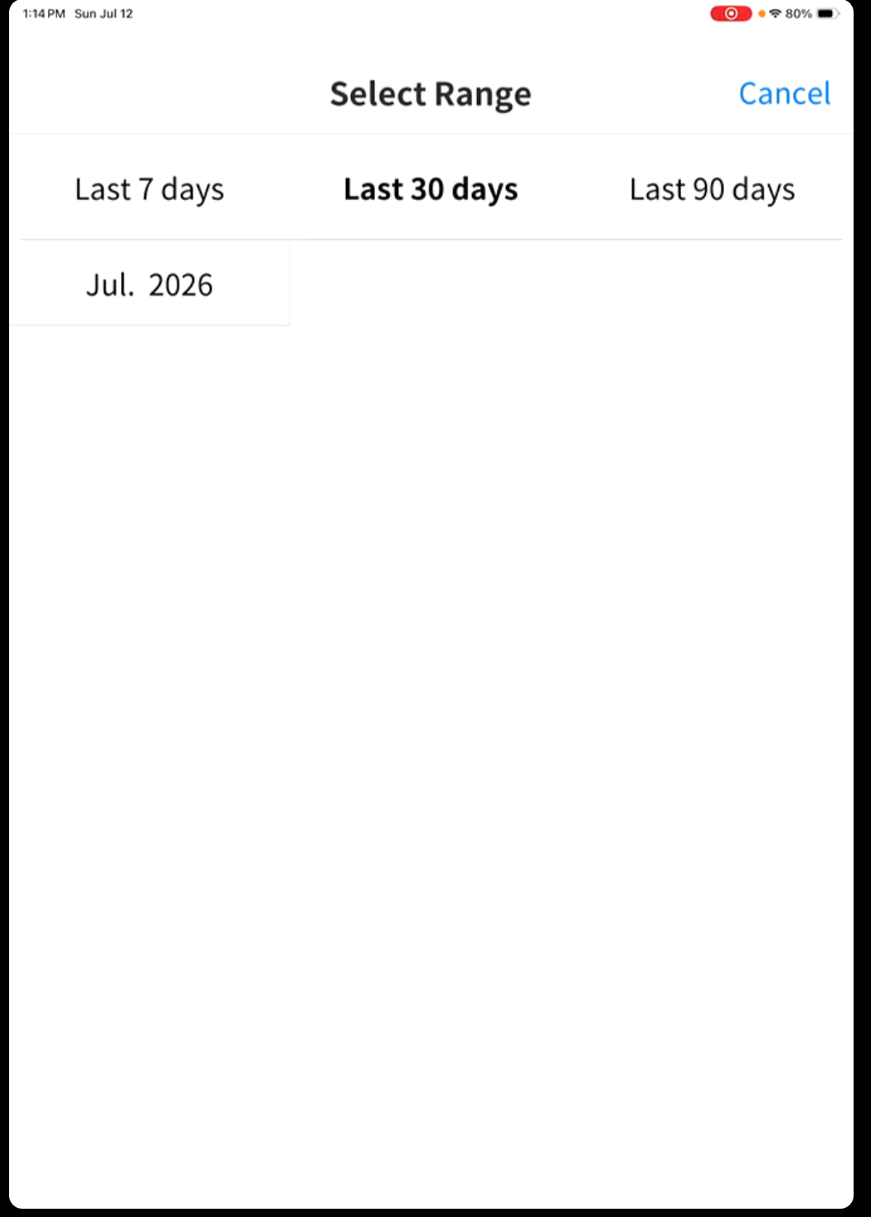

Log score by number/outcome instead of highlighting pins

Create team (see teammates if join team) – see each other’s trends. Add friends? Look up profiles? Public vs private

Handicap trend

